Create a Python script that prompts the user for a number and calculates its factorial.

The script should handle any ValueError exception that may occur if the user enters a
non-integer value.
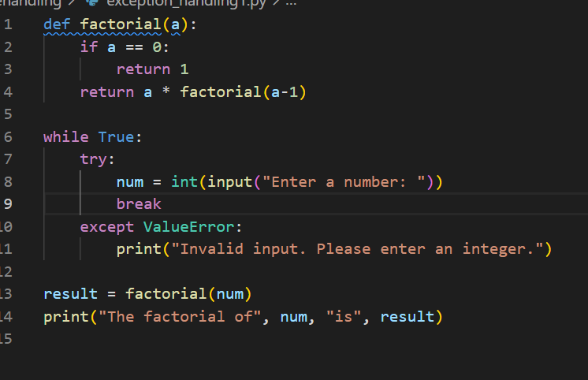
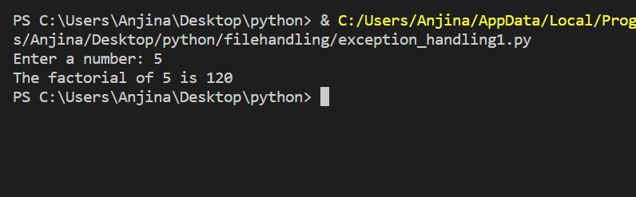

Create a Python script that reads a text file containing a list of words, one per line, and creates a
new file with the same words sorted in alphabetical order.

The script should handle any IOError exceptions that may occur when reading or writing the
files.
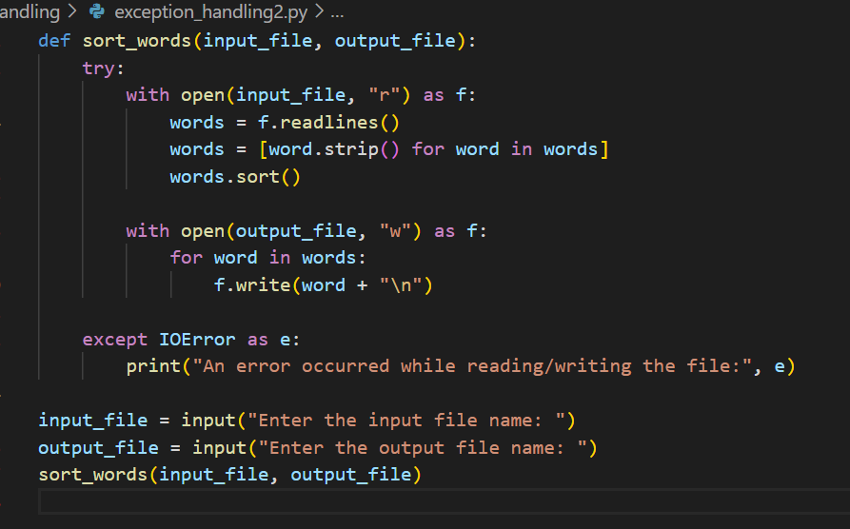
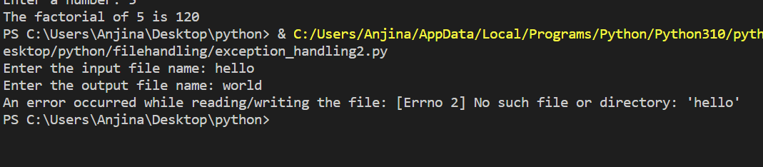

Create a Python script that reads a text file and counts the number of occurrences of a specific
word in the file.

The script should prompt the user for the file name and the word to search for, and then display
the number of occurrences of the word in the file.
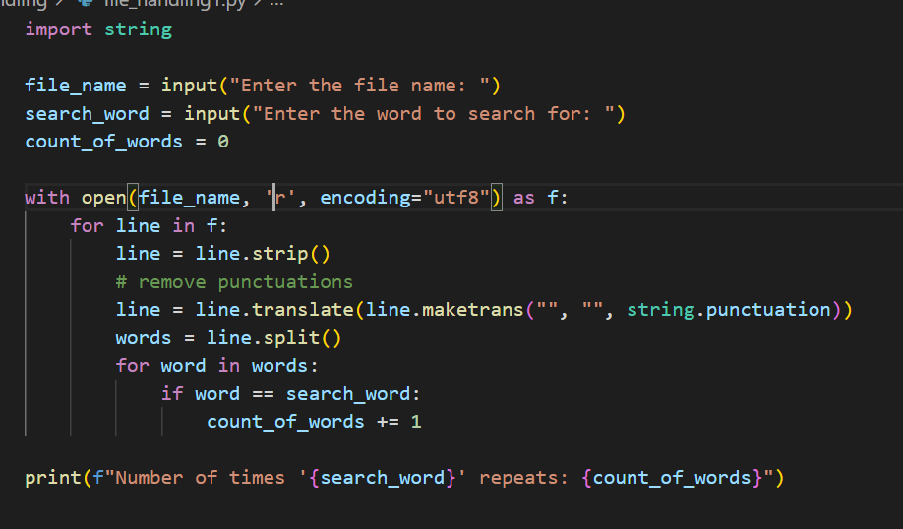

Write a Python program to read a CSV file containing employee data (name, age, salary) and
print the average salary of the employees,

handle any missing data or invalid data in the file by printing a message and continuing with the
next row.

